**Лабораторная работа №6**

**«Разработка тестового сценария.»**

**Цель работы:** приобрести навыки разработки тестовых сценариев

***Задание № 1***

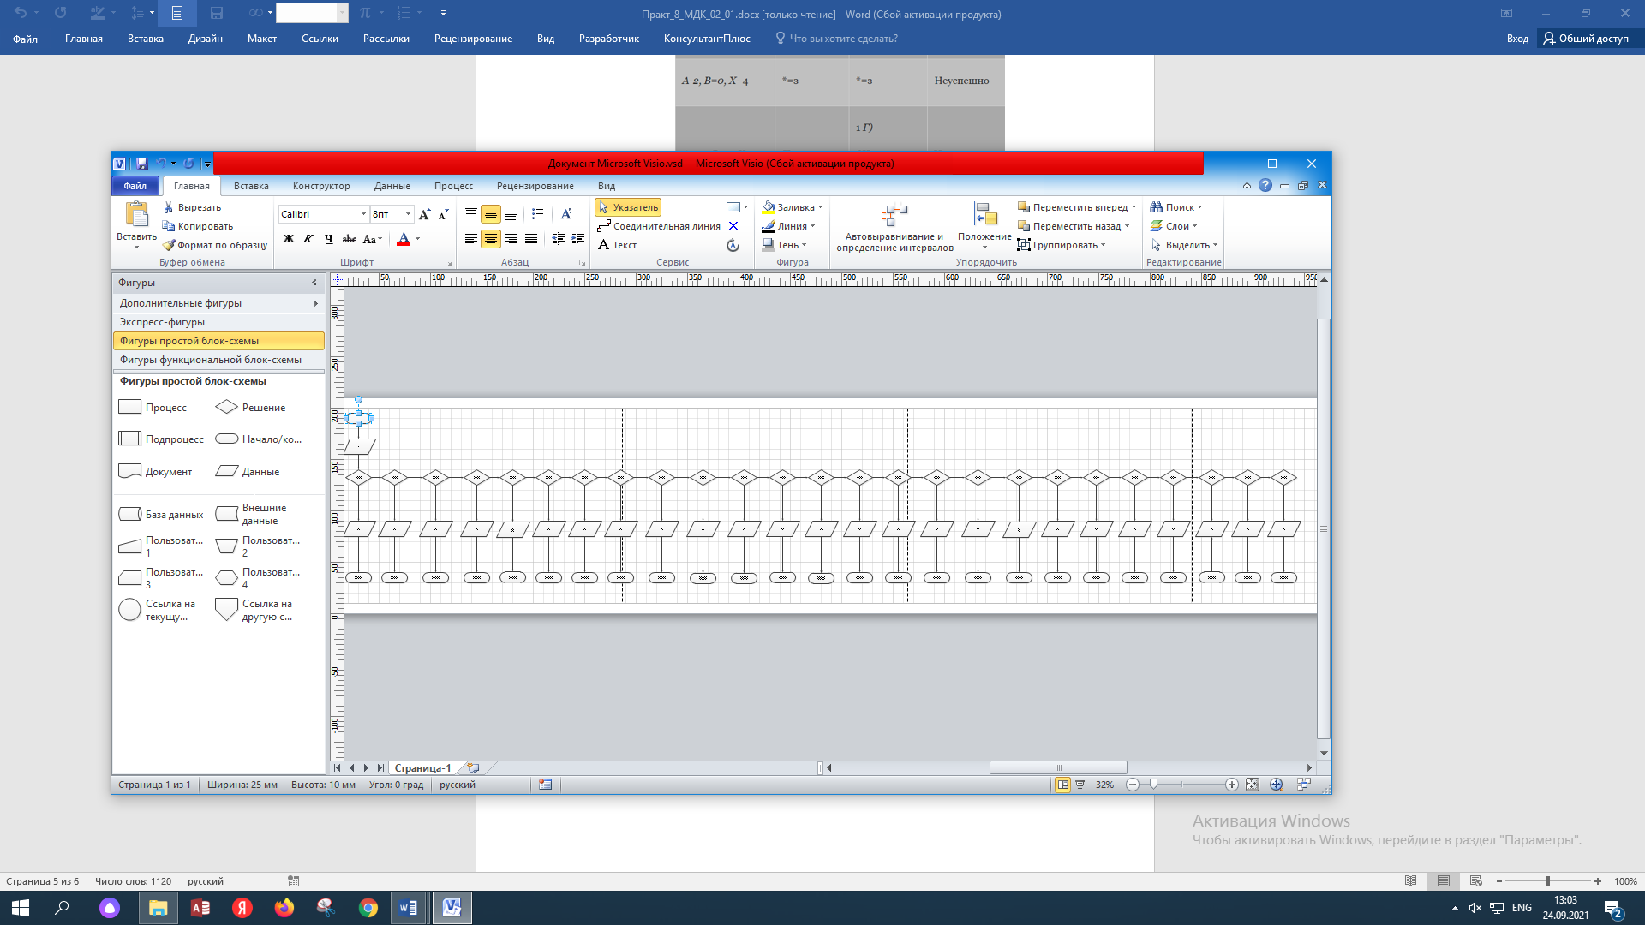

***Задание № 2***

|  |  |  |  |
| --- | --- | --- | --- |
| **Тест** | **Ожидаемый результат** | **Фактический результат** | **Результат тестирования** |
| A | 11 | 11 | Ok |
| B | 12 | 12 | Ok |
| C | 13 | 13 | Ok |
| D | 14 | 14 | Ok |
| E | 15 | 15 | Ok |
| F | 21 | 21 | Ok |
| G | 22 | 22 | Ok |
| H | 23 | 23 | Ok |
| I,J | 24 | 24 | Ok |
| K | 25 | 25 | Ok |
| L | 31 | 31 | Ok |
| M | 32 | 32 | Ok |
| N | 33 | 33 | Ok |
| O | 34 | 34 | Ok |
| P | 35 | 35 | Ok |
| Q | 41 | 41 | Ok |
| R | 42 | 42 | Ok |
| S | 43 | 43 | Ok |
| T | 44 | 44 | Ok |
| U | 45 | 45 | Ok |
| V | 51 | 51 | Ok |
| W | 52 | 52 | Ok |
| X | 53 | 53 | Ok |
| Y | 54 | 54 | Ok |
| Z | 55 | 55 | Ok |